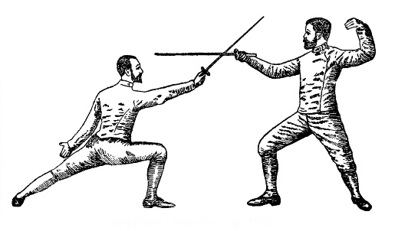
Gleann Abhann Fighter’s Collegium
February 22-24, 2019
Warner-Tully Memorial YMCA Camp
5184 Y Camp Road, Port Gibson, MS 39150
The Shire of Iron Ox invites the populace of the River Valley Realm to Fighter’s Collegium. With the Drums of War growing louder signaling that Gulf Wars drawing near, now is the time for the Mighty Ram Armies to prepare! Come and fight all day— maybe even take a non-fighting class or two— then feast and revel late into the night.
 | Site Registration/ Daytrip | Bedspace  Registration | Tenting  Registration | Feast Registration*  (Limit of 80)
Adult Member Registration | $13 | $10 | Free | $8
Adult Registration | $18 | $10 | Free | $8
Child Registration  (17 & under) | Free | $10 | Free | $5
PayPal pre-registration is available until February 8 at midnight! Reservations checks can be made out to SCA-MS, Inc, Shire of Iron Ox.
Cash only at the door!

Per Kingdom Law, no family shall pay a Site Registration higher than three (3) adult member registrations for admissions to an event as long as they all have proof of membership. This does not include bed and/or feast spaces for more than those covered by the three (3) paid adult member registrations. Family is defined as one (1) or two (2) custodial adults, plus legal dependents age 17 or under. Proof of immediate family relations and age may be required.
Autocrat Deputy Autocrat Reservationist Feastcrat
THLady Broinninn inghean Aindriasa THLord Christof D’Wynter THLord Tynk Chainbeard Mistress Ariadne de Ravenna
mka Megan Barnes called the Wolf mka Richard Goodwin mka Elizabeth Lancaster
randmbarnes2006@gmail.com mka Chris Barnes 301 Lewis Street Elancase@gmail.com
662-719-2842 (No calls after 9 pm) randmbarnes2006@gmail.com Richland MS 39218 601-988-8140
tynkfx@yahoo.com
Site Notes: Site opens February 22 at 5 pm; site closes February 24 at 10 am. Attendees still on site after this time will be part of the clean-up crew! Pets are allowed on a leash, but not in cabins. Site is very discreetly wet—no original containers! You MUST take your empties when you leave.

601-983-8145
Directions: Take best route to Vicksburg, MS. Then take the exit for I-20 W/ US-61 S. Follow US-61 S to Ingleside-Karnac Ferry Road (approx. 25 miles). Turn right onto Y Camp Road. Follow Y Camp Road to site.

Directions: From I-20 West take the Haughton Exit # 33 to LA 157 S, turn left at LA 3227 E, then a right at LA 164 E, another right at LA 163 S/Pearl Harbor Ave and turn left at State Park Rd. From Minden I-20 take LA 371 south to Sibley, LA 164 west to Doyline, and LA 163 south to the park. Park gate closes at10pm: For those who will be arriving after 10pm, please contact the Event Steward after 5pm on the Friday of the event for the gate code.

