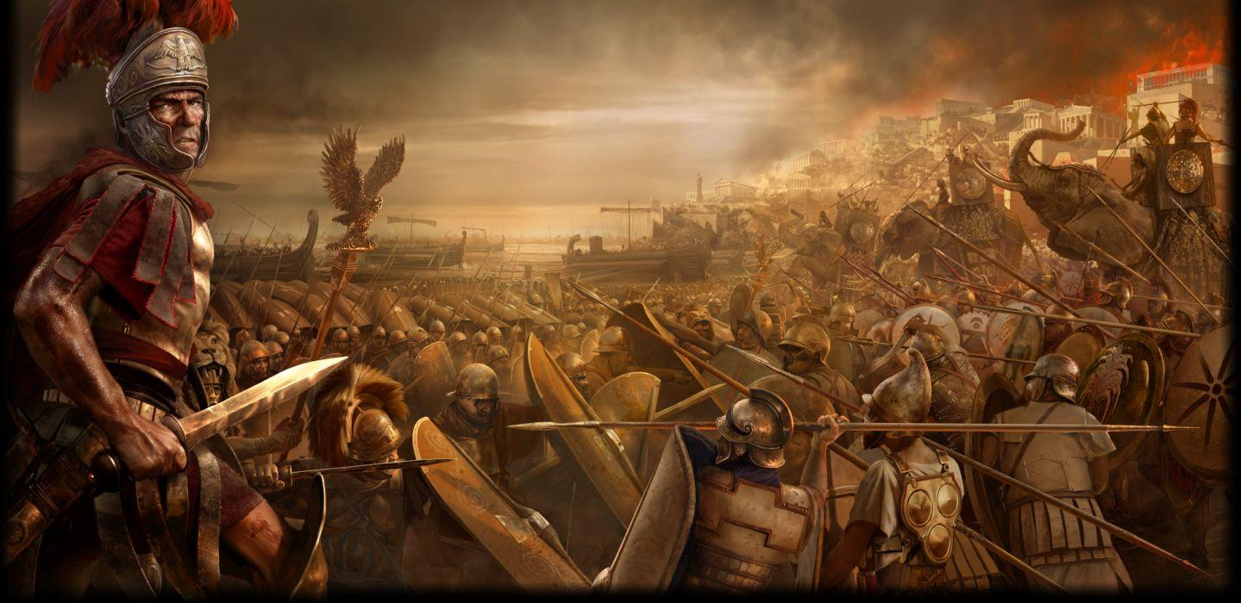
Gleann Abhann’s Fighters’ Collegium
on February 24-26, 2023
Camp Silver Creek
1608 Hwy 586; Foxworth, MS 39483

The Shire of Dragoun’s Weal invites you to join us as the Order of the Chivalry gives a weekend of fighting classes: single and melee combat. Contact the Gleann Abhann Earl Marshal Sir Carson Wynne for details. earlmarshal@gleannabhann.net
A live-weapons’ tournament in honor of her Majesty, Sultan Jacquette.
Hammar and Wulf households will be providing a fundraiser lunch to benefit Their Majesties’ “Shepherd’s Table”.

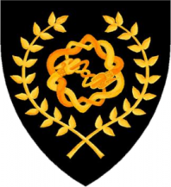
Please contact by text message or email.
Autocrat: AEoelbeorht of Harduic seneschal@dragounsweal.gleannabhann.net 601-467-3318
Feastcrat: Baroness Gentile D’Orleans gendorleans@gmail.com 601-323-0599
Reservations: Mistress Isabella D’Arques Izibella@bellsouth.net 601-382-0577

Registration Schedule

PayPal accepted until:
Friday, February 17, 2023
Cash only at the door.
ALL RESERVATIONS MUST BE MADE THROUGH PAYPAL AT THIS TIME.
 | Entry | Cabin | Tenting | Feast
Adult Member Registration | $15 | $10 | $5 | 10
Adult Registration | $20 | $10 | $5 | 10
Child Registration (17- under) | FREE | $10 | FREE | $5  (under 12 Free)
Note: Day Trip is Entry only; otherwise add categories that meet your registration needs. Family Max is 3 adult prices w/proof of membership, but does not include bed or feast. Minors must be accompanied by a parent/legal guardian/designated adult with signed waivers.

Directions: Address in Google Maps works, or easiest route to Hwy 586 west of Columbia, MS. Once on Hwy 586 continue to follow SCA signs to Camp Silver Creek. Site opens at 5pm Friday and closes at 11am Sunday. Discreetly wet: No original containers, remove empties from site. Pets leashed.

