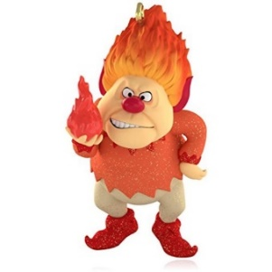
The Barony of Axemoor
Presents
Christmas Revel 2022
The Battle of Oak & Holly
December 2nd – 4th, 2022
As the seasons change, a challenge is issued among the Kingdom. Are you a cool & frosty Southerner or are you Sourthern steamy hotness? The Kings of Oak and Holly demand you declare yourself! Join us in the Southern reaches of Gleann Abhann in deciding who is right.
This is almost as divisive as Crunchy or Creamy…but not.
Join us in declaring sweater or air conditioner… less or more clothing…. pumpkin spice or mint! It’ll be chaotic. It’ll be hot. It’ll be cool. You don’t wanna miss this.
 | Site Registration  Daytrip Registration | Bedspace Registration | Tenting Registration | Feast Registration
Adult Event Registration | 20 | 5 | - | 10
Adult Member Discount Event Registration | 15 | 5 | - | 10
Child Registration (17 and Under) | - | 5 | - | 10
Autocrat | Co-Autocrat & Reservationist |  | Feast-crat
Ld. Andrew Mac Corryn | Sir Gellir Gunnarsson |  | THL Emma Grey
MKA: Drew Moore | MKA: Chris Bass |  | MKA: Jerri Moore  Ladyemmagrey@gmail.com  601-384-7544  No Calls after 10 PM
mdrewmoore@gmail.com | gellir@att.net
601-773-0152  no calls after 9 PM | 817-372-1017  No Calls after 10 PM
Location
*Mississippi Elks Camp*
*67 Lomas Rd, Hattiesburg, MS 39401*
Children 17 and under do not pay a site registration for admission to an event. Child registration DOES NOT include fees for feast or bed registration. This means children 17 and under must pay stated add-on costs for feast and bed space per child as stated by hosting group. Minors must be accompanied by a parent, legal guarding or custodial adult with signed waiver.
PayPal deadline is the 18th of November at midnight.
Site opens @ 5 PM December 2nd and closes at 10 AM December 4th.
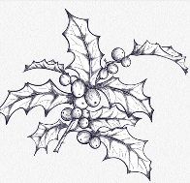
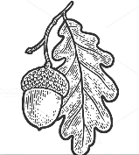
Make checks payable to: SCA, Inc. Barony of Axemoor
Although the SCA complies with all applicable laws to ensure the health and safety of our event participants, we cannot eliminate the risk of exposure to infectious diseases during in-person events. By participating in the in-person events of the SCA, you acknowledge and accept the potential risks. You agree to take any additional steps to protect your own health and safety and those under your control as you believe to be necessary.

